ReactJS Hands-On Lab 2 - Output Report

Objective
Create a React application "StudentApp" with three components: Home, About, and Contact, each displaying respective messages.

Environment Setup & Project Creation
Created a new React project using create-react-app and verified project creation:
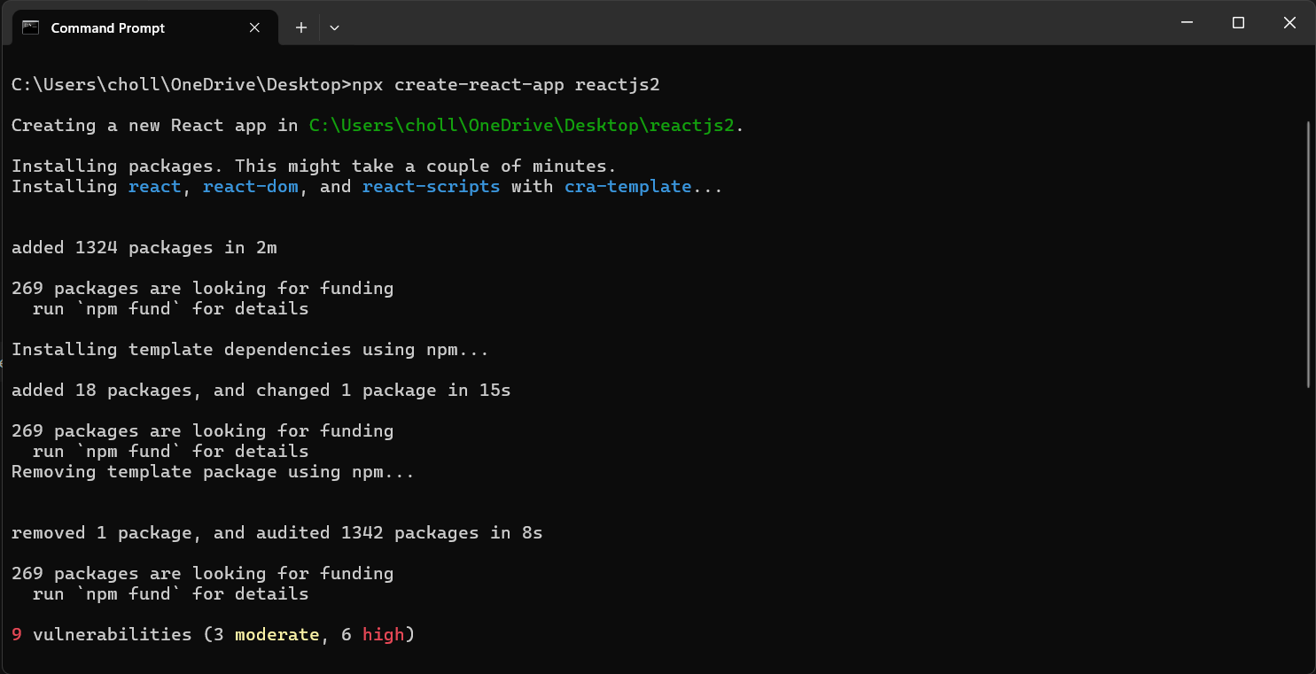
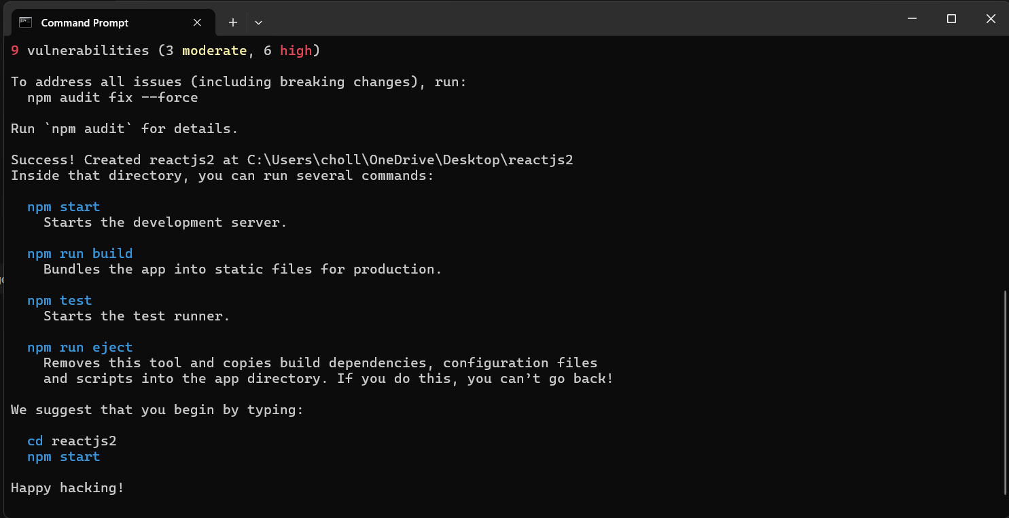

Project in VS Code
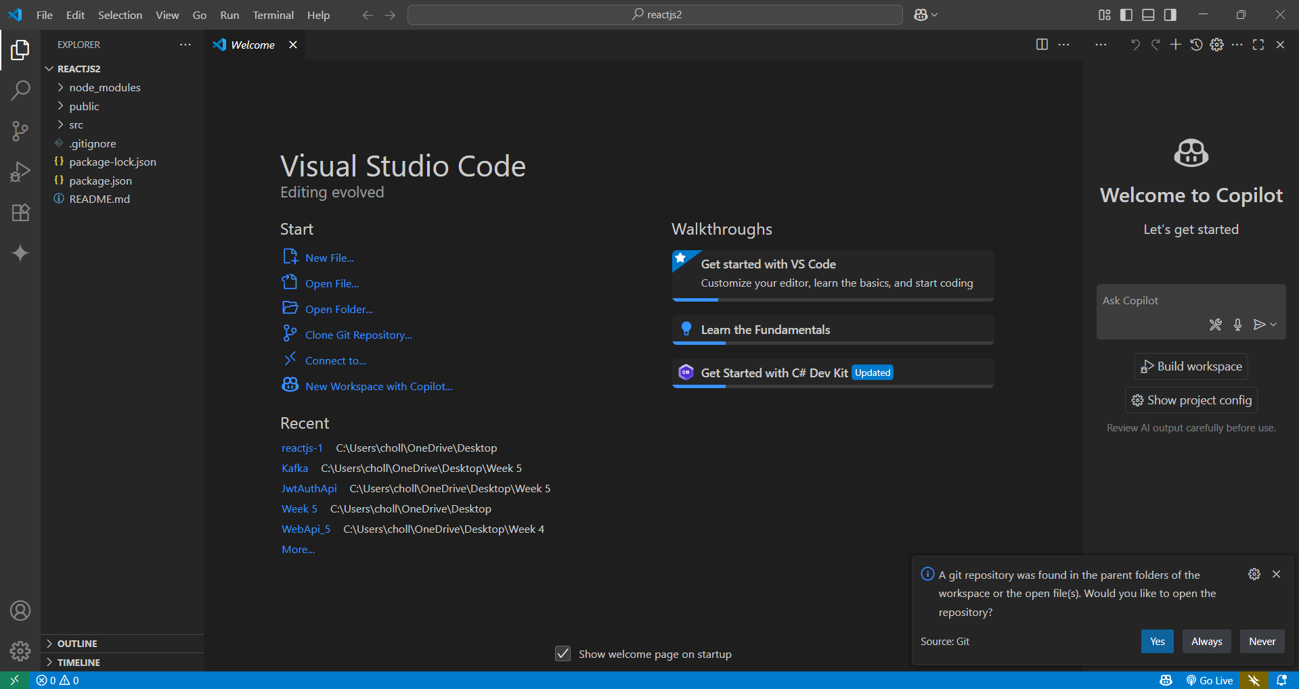

Components Creation
Created the following class components: Home, About, and Contact under src/Components folder:
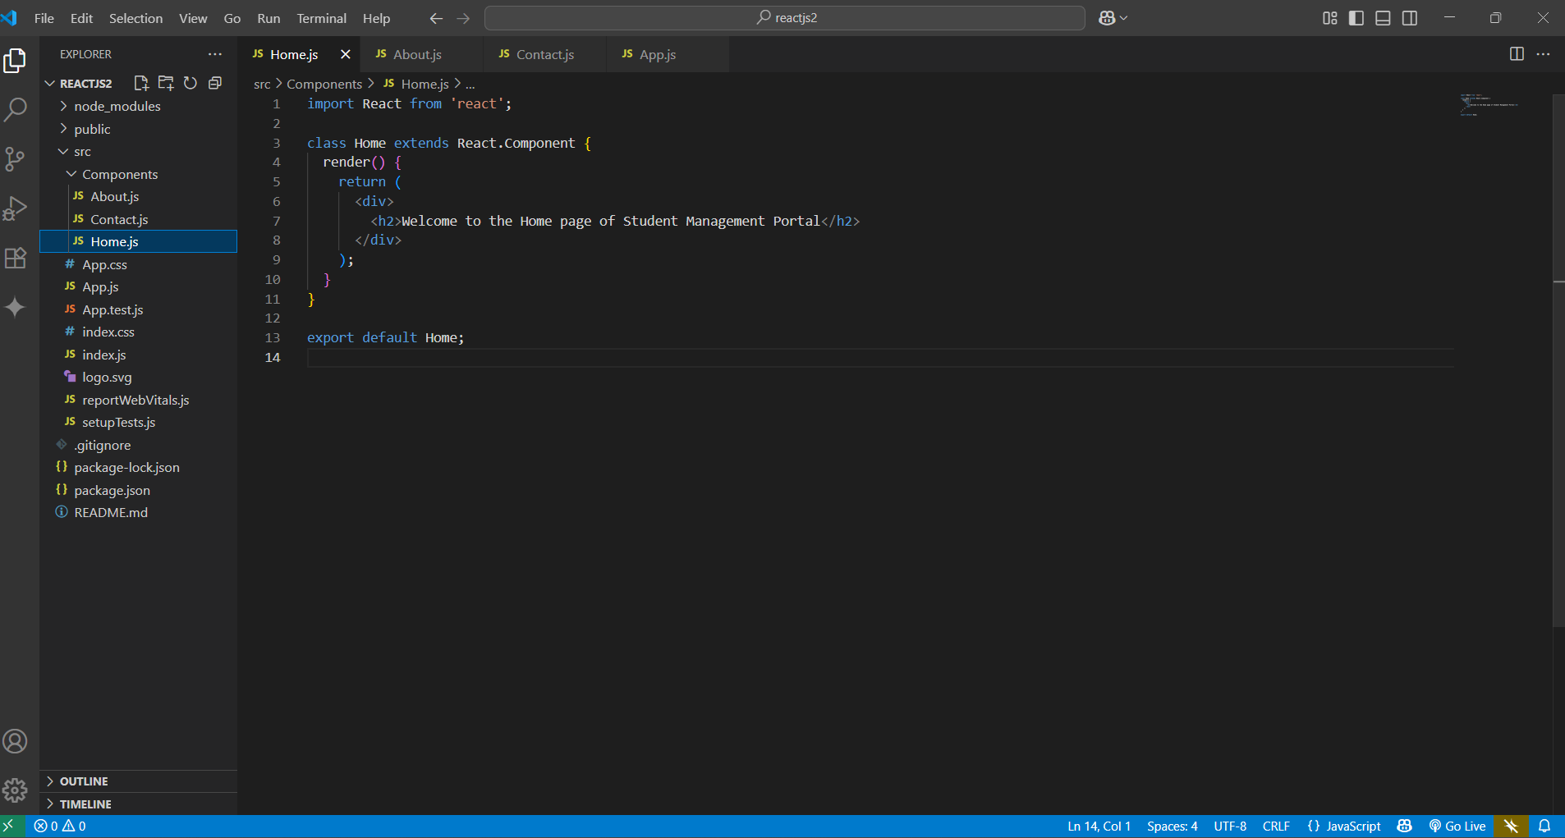
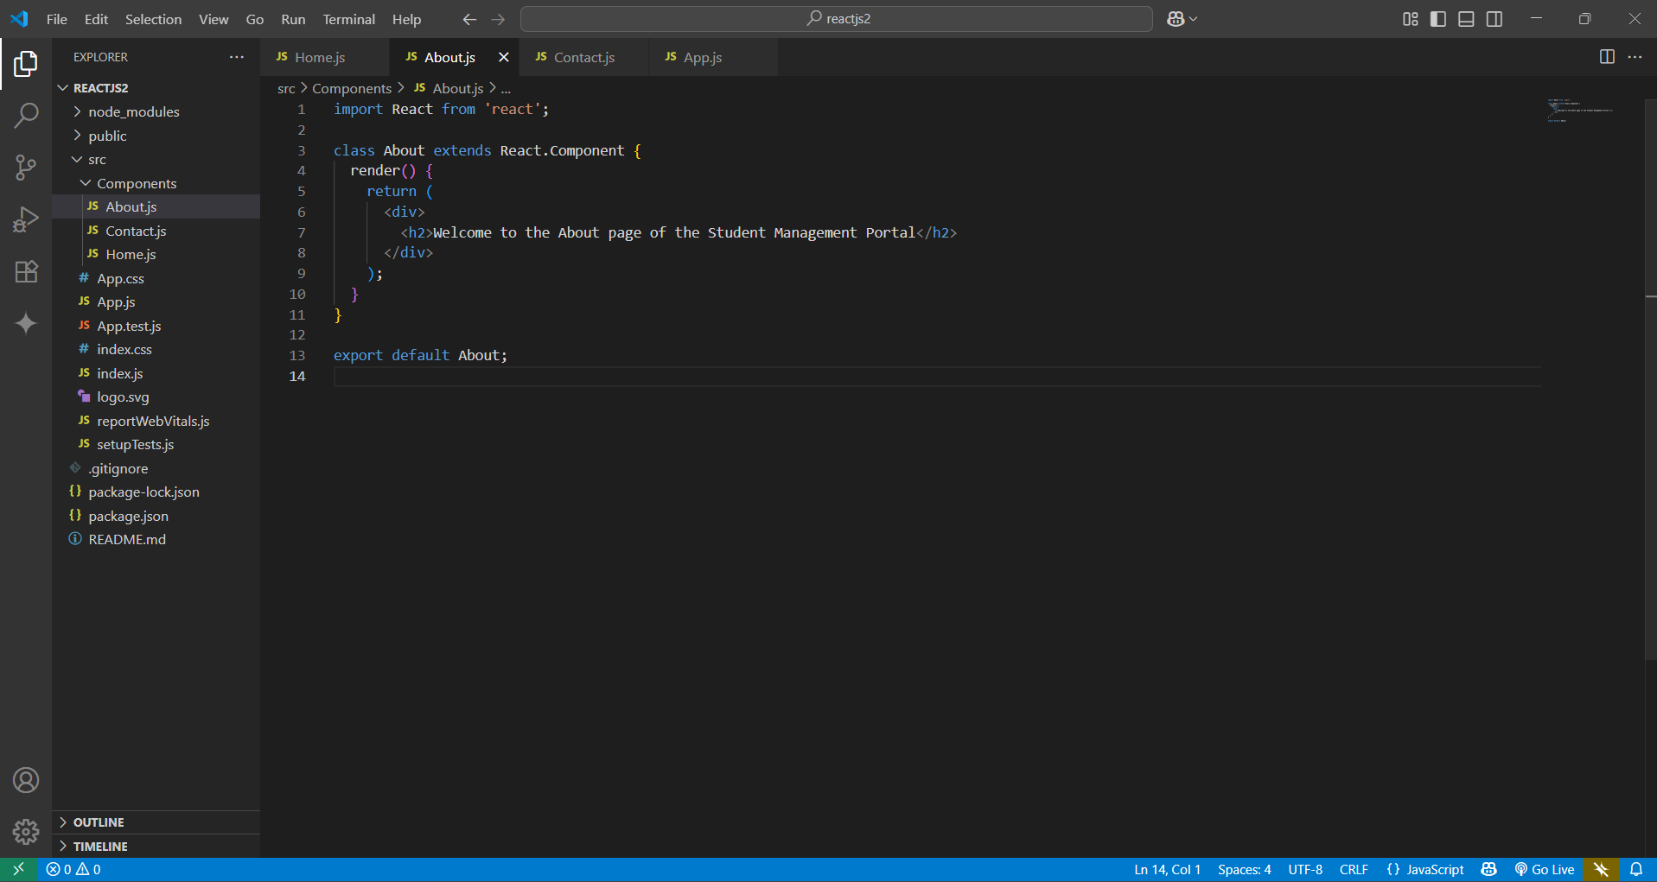
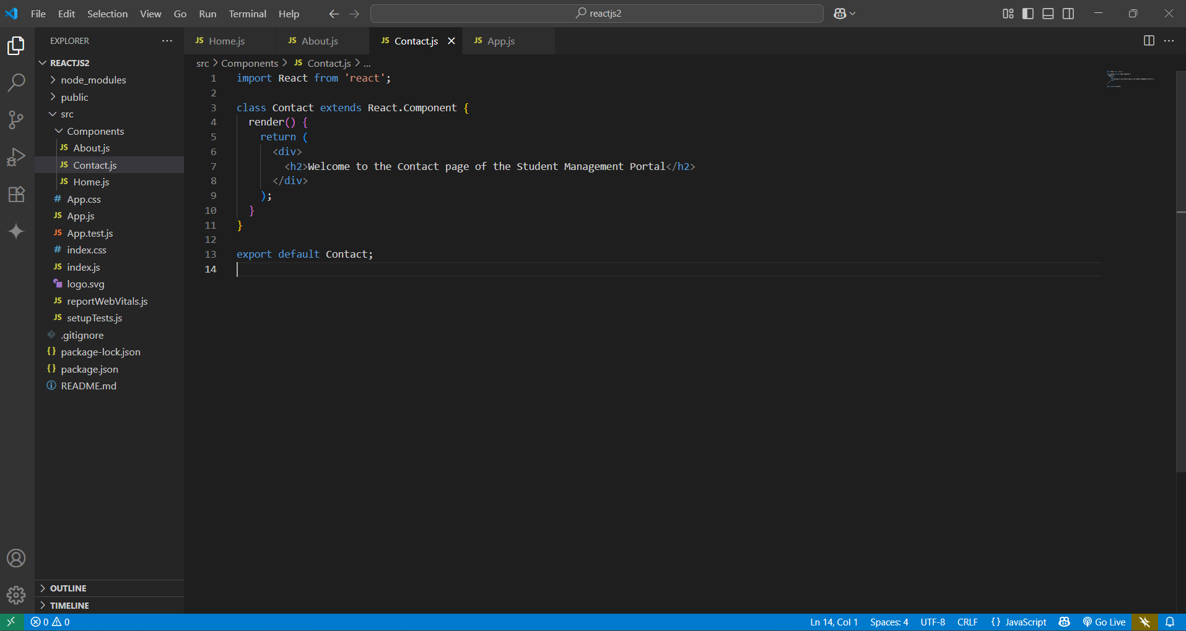

Edited App.js
Edited App.js to call all three components:
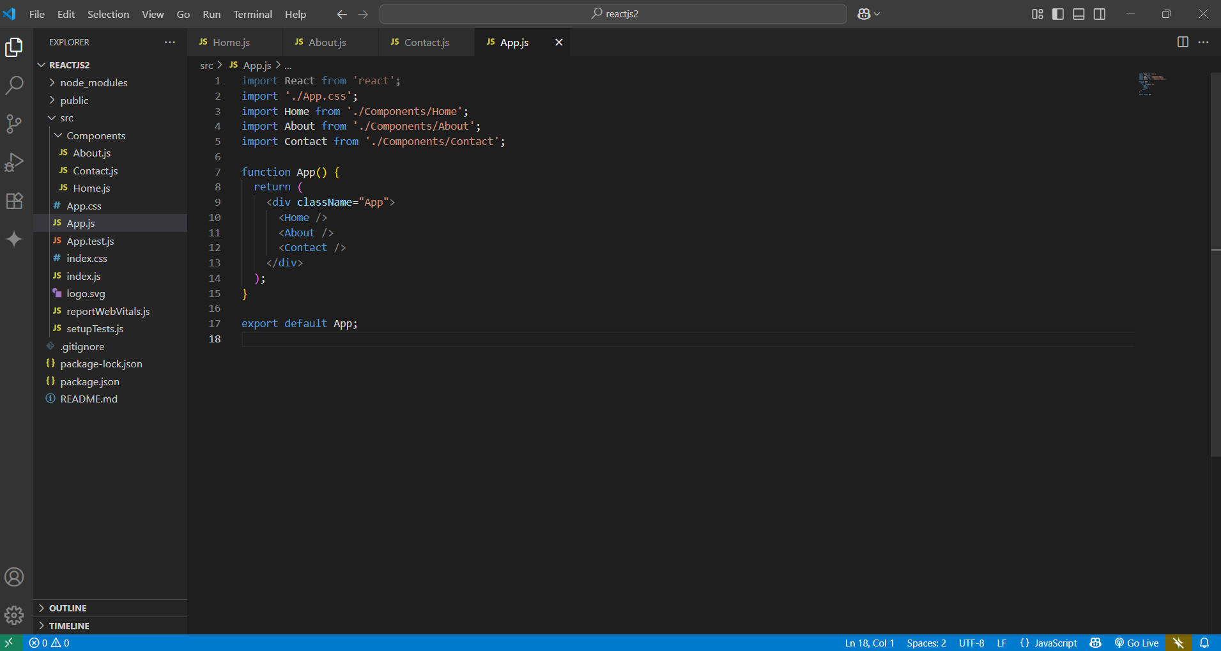

Webpack Compilation
Started the development server and verified successful compilation:
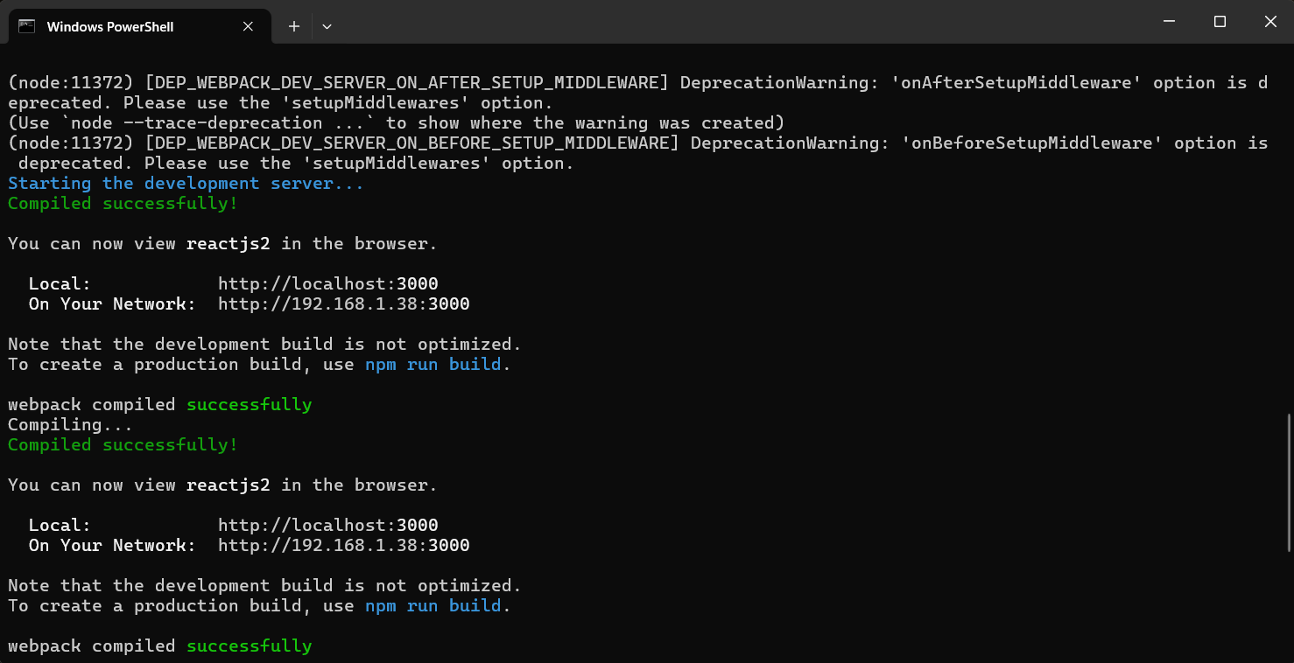

Browser Output
Verified that the React app displays all three component messages in the browser:
